KARNATAK LAW SOCIETY’S

GOGTE INSTITUTE OF TECHNOLOGY

UDYAMBAG, BELAGAVI-590008

(An Autonomous Institution under Visvesvaraya Technological University, Belagavi)

**(APPROVED BY AICTE, NEW DELHI)**



**Activity Report**

**ACADEMIC YEAR : 2023-24**

|  |  |
| --- | --- |
| **Name of the Club** | **ACM Student Chapter** |
| **Subject** | **Club activities** |
| **Subject Code** | **21AECCV75** |
| **Student Name** | **Nandeesh B Hiremath** |
| **USN** | **2GI21IS025** |
| **Branch** | **Information Science and Engineering** |
| **Sem & Div** | **5th Semester** |
| **Roll No** | **35** |

**Marks scored at the end of each Activity / Project**

**( Note : Max marks each activity/project - 25 )**

|  |  |  |  |  |  |
| --- | --- | --- | --- | --- | --- |
| **S. No.** | **Activity / Project title** | **Date** | **Sem** | **Marks obtained** | **Faculty sign** |
| 01 | NLP workshop | 09/10/23 - 13/10/23 | 5th |  |  |
| 02 | Outreach Program | 05/01/24 - 06/01/24 | 5th |  |  |
|  |  |  |  |  |  |
|  |  |  |  |  |  |
|  |  |  |  |  |  |
|  |  |  |  |  |  |
|  |  |  |  |  |  |
|  |  |  |  |  |  |

**Marks scored at the end of the course**

|  |  |
| --- | --- |
| **Max CIE Marks** | **100** |
| **Obtained CIE**  **Marks** |  |

**Name & Signature of the faculty Coordinator**

**Activity - 1**

**Title :** NLP workshop **Semester :** 5th

**Date:** 09/10/2023 – 13/10/2023

**Place**: KLS Gogte Institute Of Technology, Belgaum

**Aim/Objective:** To provide participants with a comprehensive understanding of Natural Language Processing (NLP) techniques and tools through hands-on learning experiences.

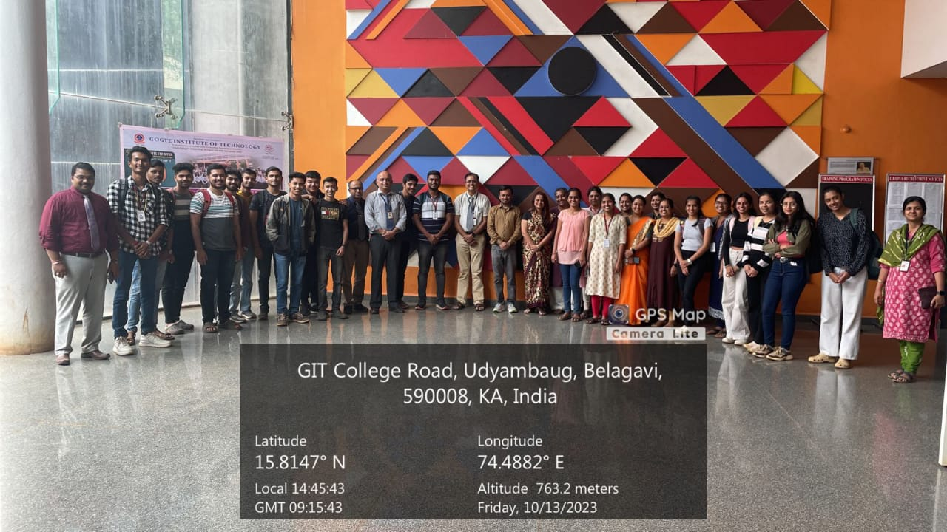

**Day 1:**

Participants learnt essential data manipulation skills using NumPy and Pandas, along with data visualization techniques using Matplotlib. By the end of the day, they will be proficient in handling arrays, data frames, and creating various types of plots, setting a strong foundation for further exploration in NLP.

**Day 2:**

The focus shifts to text preprocessing and machine learning basics. Participants will gain practical experience in cleaning and analyzing textual data, understanding sentiment analysis, and exploring machine learning architectures relevant to NLP applications, laying the groundwork for more advanced tasks in subsequent days.

**Day 3:**

Participants dig into advanced topics such as data annotation, setting KPIs for healthcare applications, and addressing challenges with imbalanced datasets. Additionally, they will explore conversational AI applications, integrating text extraction and question-answering techniques, enhancing their understanding of real-world NLP use cases.

**Day 4:**

The day emphasizes refining NLP tasks with techniques like spelling correction, vector databases, and sentence similarity measurements. Participants will gain insights into enhancing the accuracy and efficiency of NLP applications, preparing them for more sophisticated tasks like text summarization and named entity recognition.

**Day 5:**

The workshop concludes with hands-on sessions on text summarization, named entity recognition, and a reinforcing quiz, consolidating participants' understanding of NLP fundamentals and advanced techniques. By the end, they will be equipped with practical skills and knowledge to tackle diverse NLP challenges effectively.

**Signature of the student Signature of the faculty**

**Activity - 2**

**Semester :** 5th

**Title:** Outreach Program.

**Date:** 05/01/2024-06/01/2024

**Place:** Balika Adarsh High School, Belgaum

**Aim/Objective:** The aim is to equip students with a comprehensive comprehension of fundamental computer hardware and software, promoting efficient recognition, characterization, and application.

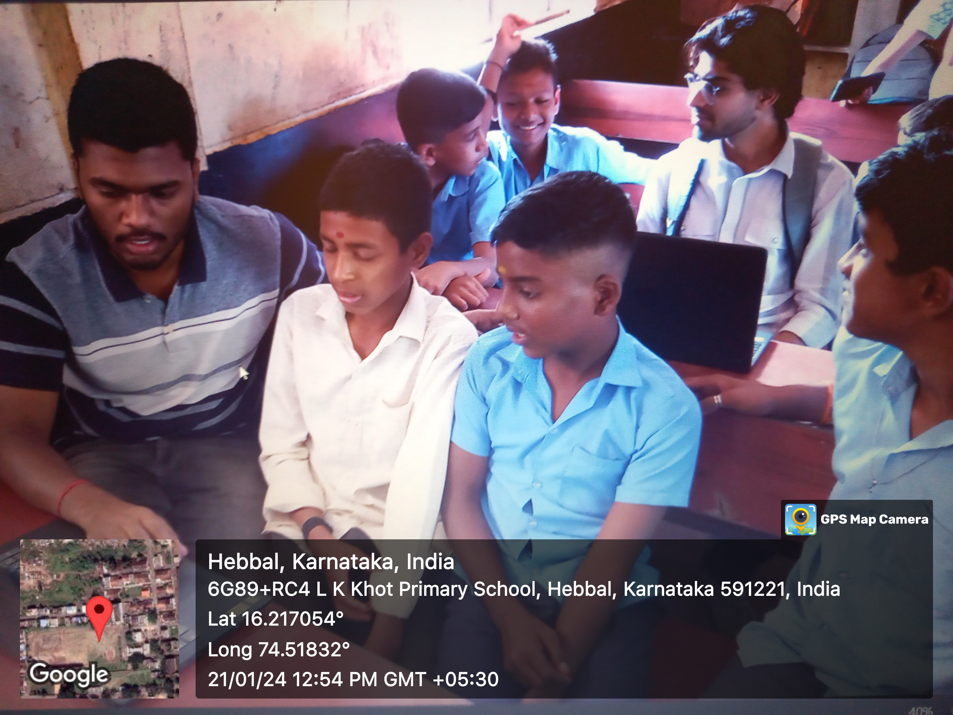

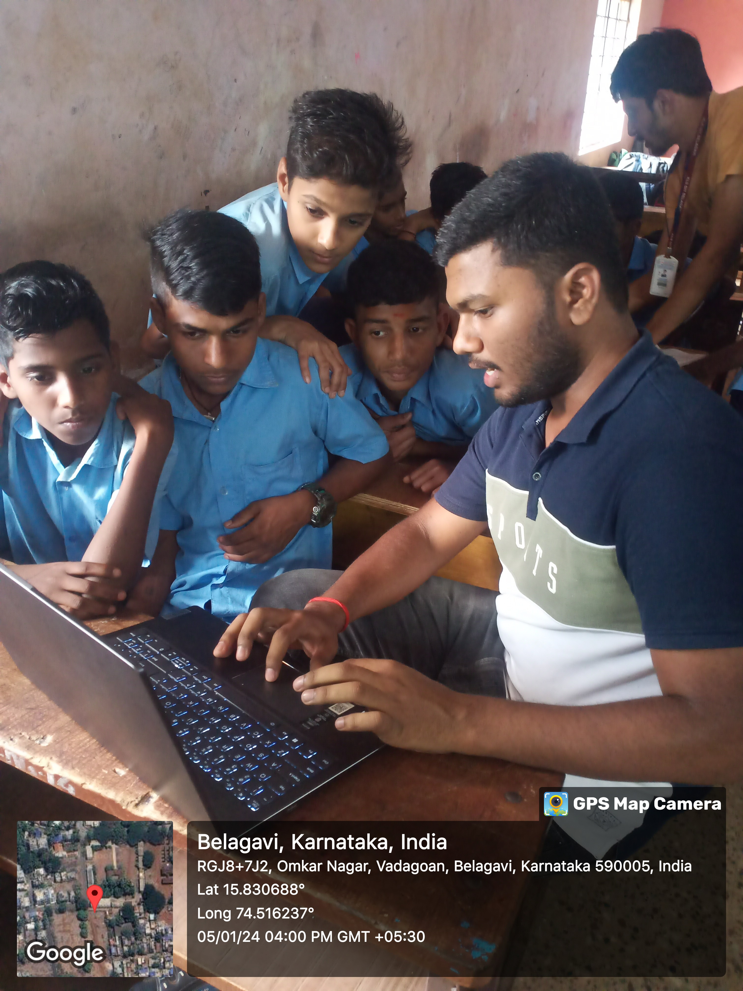

Day 01 Day 02

**Day 01:**

Students were given a thorough overview of the essential components of computer hardware on the first day of the curriculum by introducing them to basic ideas. A review of key software programs, including Microsoft Word, Excel, and PowerPoint, was also covered in the course. The objective of this module was to provide students with a strong foundation in computer systems and to help them get familiar with important software tools.

**Day 02:**

Comprehensive Software Utilization: During the second day of instruction, students worked through real-world tasks to improve their comprehension and skill with using basic software programs, particularly Microsoft Word, Excel, and PowerPoint. The emphasis was on hands-on experience, allowing students to navigate and grasp the sophisticated capabilities of each application efficiently.

Improved Document Development and Presentation Skills: A major part of Day 02 was devoted to helping students improve their document creation and presentation abilities. Through focused instruction and hands-on practice, students were able to put their newly acquired knowledge to use in formal letter writing and presentation crafting. The objective was to enable students to use the entire range of features provided by the software tools to articulate written communication effectively.

**Signature of the student Signature of the faculty**